**A Dual-Transfer Learning Framework for Composite Properties Prediction**

**Xun Zhou**1#**, Peng Zhang**1 **and Keke Tang**1**\***

1School of Aerospace Engineering and Applied Mechanics, Tongji University, Shanghai 200092, China

# Presenter: zhoux@tongji.edu.cn

*Corresponding author: kktang@tongji.edu.cn

**Abstract:**

This study proposes a multimodal deep learning framework combining convolutional neural networks (CNN) and multilayer perceptrons (MLP) to predict nine anisotropic homogenized mechanical properties. Three input modalities are used: fiber cross-sectional images, structural encodings (001 circular, 010 ellipse, 100 trilobe, 011 square, 101 triangle), and material parameters, with spatial and cross-modal attention enhancing feature fusion. A “pretraining-dual transfer” strategy is introduced: the model first learns from 2,025 defect-free T300/7901 samples, then transfers to M40J/ZL301 and void-containing structures via selective layer freezing and fine-tuning. Results show the pre-trained model achieves R² > 0.9 and MAPE < 4% for most elastic parameters. Both material and void transfers need only 300 samples (85% reduction), maintaining MAPE < 2.6%, improving accuracy, and reducing training time by 80% and 65%, respectively. Further analysis reveals voids mainly affect matrix-dominated properties, lowering transverse moduli while longitudinal ones remain stable. This framework offers an efficient tool for rapid mechanical property evaluation of composites with realistic microstructures, advancing digital design and reliability assessment in aerospace and beyond.

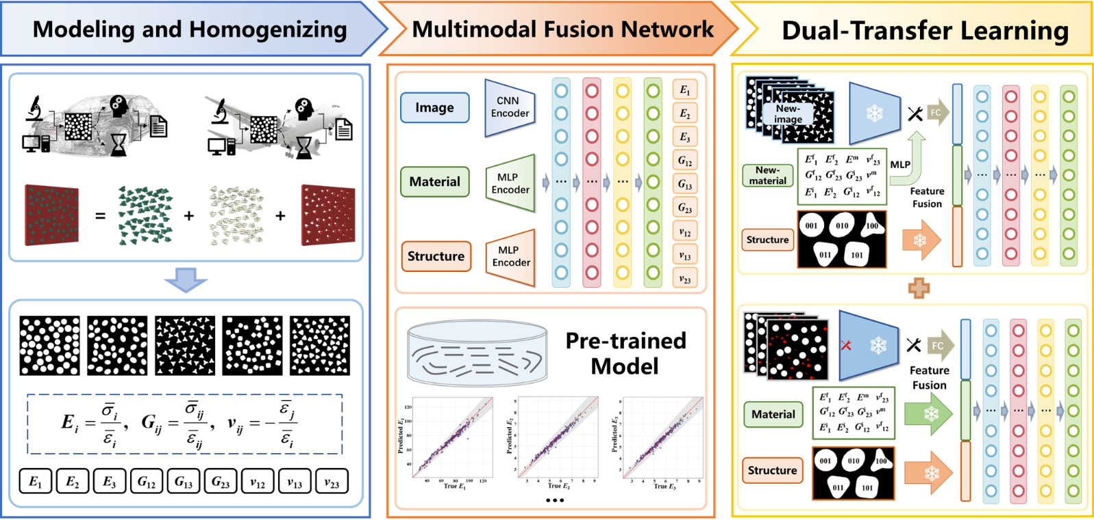

Figure 1. Multimodal fusion framework with dual-transfer strategy for composites.

**References:**

Wang Z, Wang S, Ma C, et al. The prediction of homogenized effective properties of continuous fiber composites based on a deep transfer learning approach. Composites Science Technology, 2025; 262: 111050.

Zhang P, **Zhou X**, Liang R, et al. Multi-scale semantic segmentation for fiber identification and 3D reconstruction of unidirectional composite. Composites Science and Technology, 2025; 265: 111160.

Li M, Li S, Tian Y, et al. A deep learning convolutional neural network and multi-layer perceptron hybrid fusion model for predicting the mechanical properties of carbon fiber. Materials & Design, 2023; 227: 111760.